1.

For this week, I learned the general concepts like the architecture of Kurbenets and how it work upon an application – why people using it through lecture notes. In addition, I learned additional linux command related to K8s like to deploy a project / application based on Docker Image stored at Local Docker Registry and how to manipulate it like scale it up (sadly, not yet know how to scale it down). Eventhough, Kurbenets is briefly introduced in this week material but it still took me quite a while to grasp it through research additional sources. Last but not least, I learned how to write basic YAML file and is demonstrated to sub-task 3.

2.

Task 1 – Remembering Docker

I used command “docker image ls” to check the list of existing images

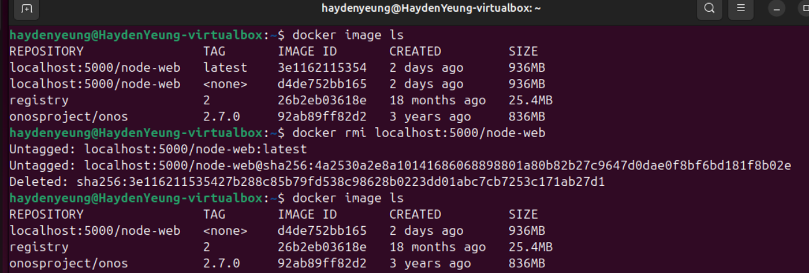

The first image (tagged with “latest”) is easily removed with “docker rmi localhost:5000/node-web”

However, I have to used command “docker image prune -a” to remove it – perhaps due to being untagged or remove it through its <IMAGE ID>.

Task 2 – Have a play!

Kubectl get all

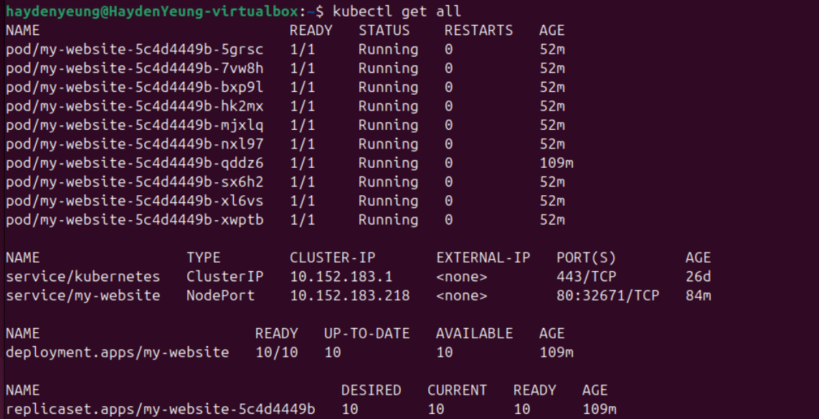

Kubectl get all --all-namespaces

Kubectl get deployment my-website -o yaml

Kubectl explain deployment

Kubectl explain deployment.status

It is found that explain deployment.status given information in the “Fields:” section

Kubectl get pod <pod name> -o yaml

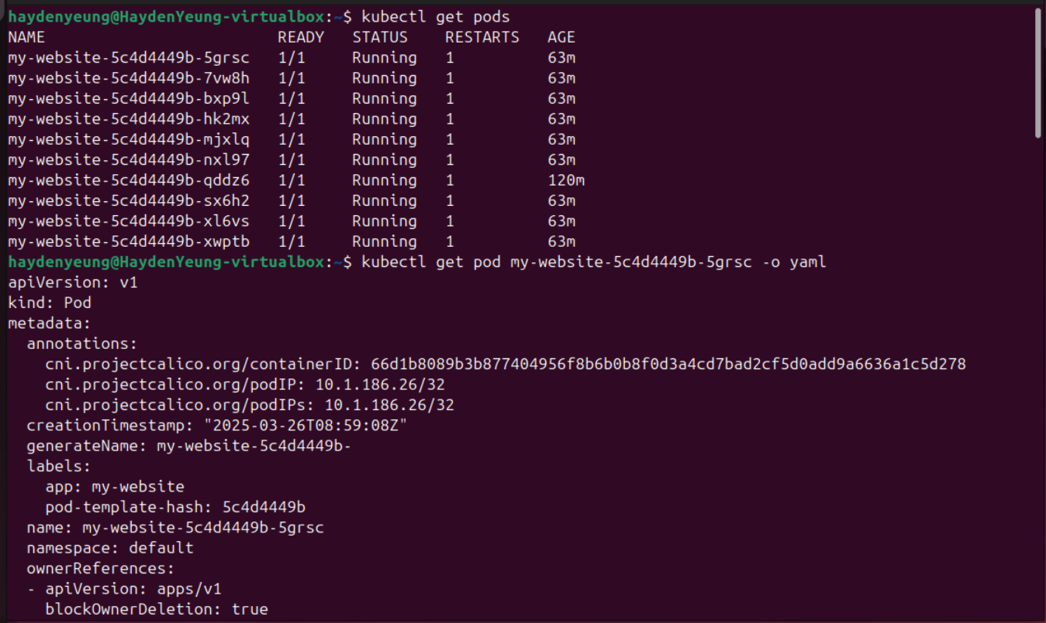

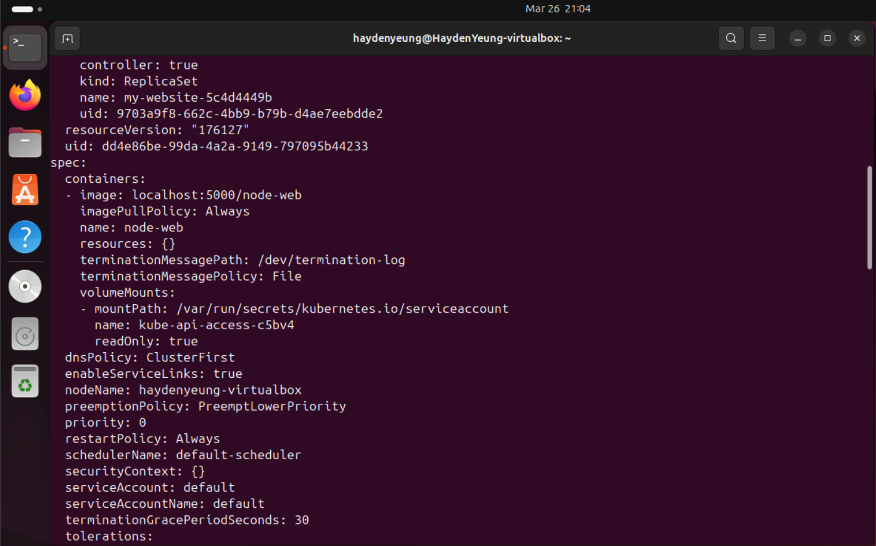

Kubectl explain pod

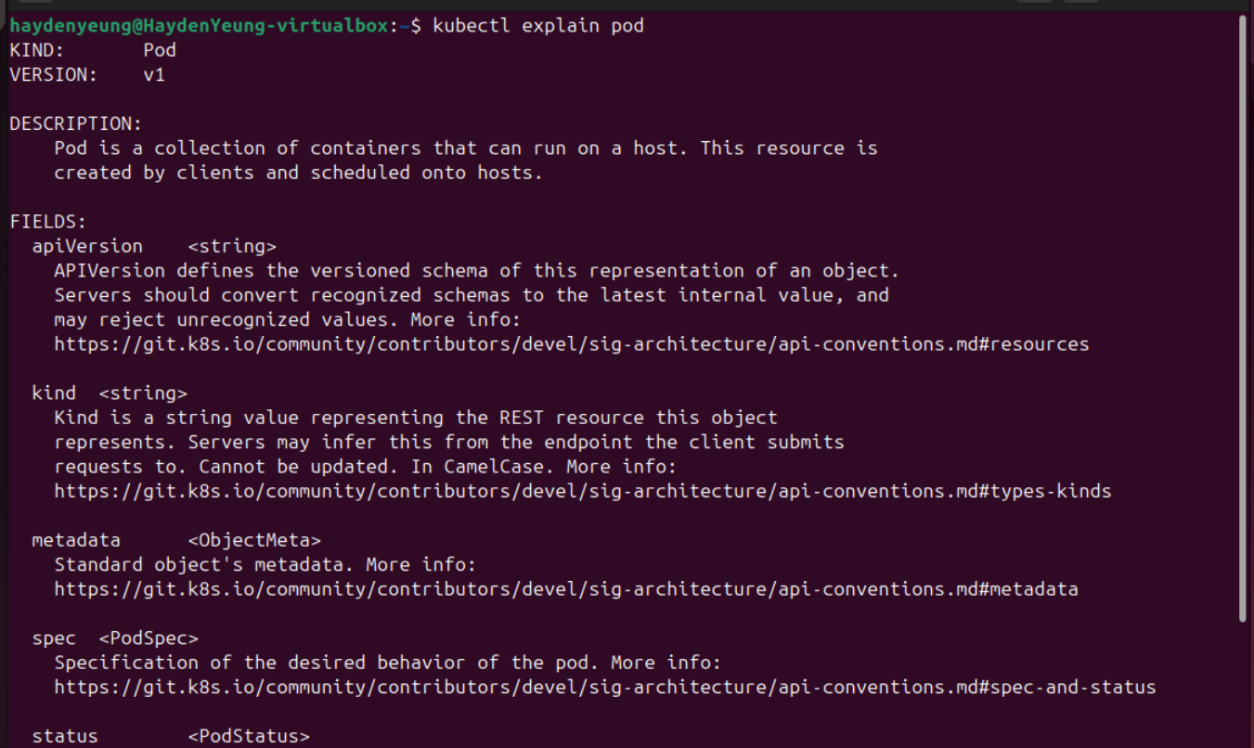



Kubectl explain pod.spec

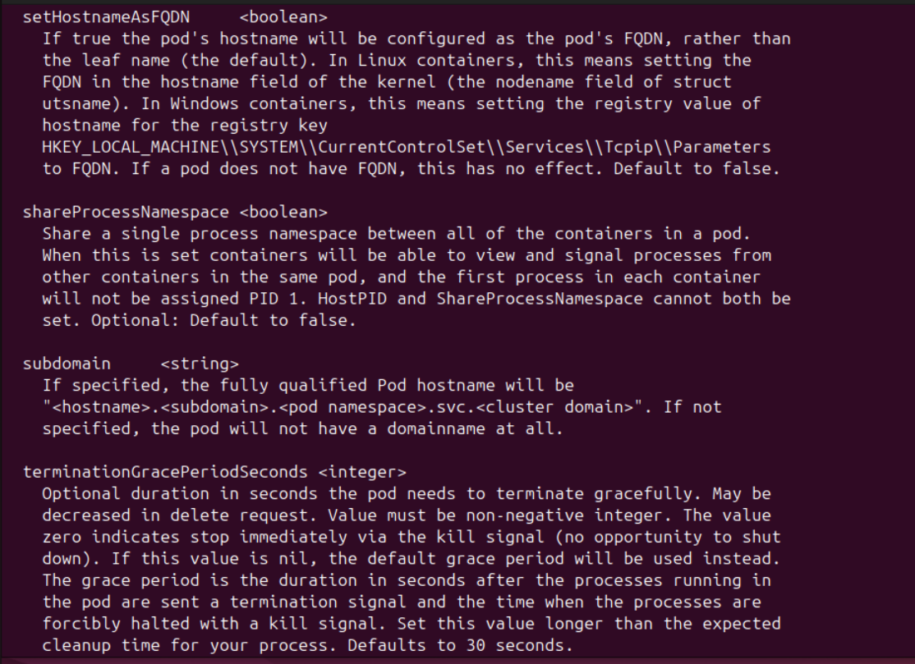

Kubectl delete pod <pod name>

I found that after deleting one of the running pod, a new pod is created (-jdfbd in case) which is understandable due to the nature of maintaining the number of replicas at all time.

3.

---

student:

name:

family_name: “Duong”

given_name: “Tam Lac”

preferred name: “Hayden”

enrolled_units:

- unit_code: “SIT226”

unit_name: "Cloud Automation Technologies”

mode: “Online”’

- unit_code: “SIT305”

unit_name: "Mobile Application Development”

mode: “Online”

- unit_code: “SIT323”

unit_name: "Cloud Native Application Development”

mode: “Online”

- unit_code: “SIT374”

unit_name: "Team Project (A) – Project Management And Practices”

mode: “Online”

timetable:

monday:

- activity: "Lecture"

time: "10:00 - 12:00"

location: "Online"

channel: “Microsoft Team SIT226-SIT727 Cloud Automation Technologies”

- activity: "Lecture"

time: "10:00 - 12:00"

location: "Online"

channel: "Microsoft Team SIT374-SIT764 Team Project (A) – Project Management And Practices"

tuesday:

- activity: "Lecture"

time: "10:00 - 12:00"

location: "Online"

channel: “Microsoft Team SIT323-SIT737 Cloud Native Application Development”

- activity: "Workshop"

time: "17:00 - 19:00"

location: "Burwood"

room: “Building HE, Room 1.010”

wednessday:

- activity: "Lecture"

time: "12:00 - 14:00"

location: "Online"

channel: “Microsoft Team SIT305-SIT708 Mobile Application Development”

thursday:

- activity: "Workshop"

time: "11:00 - 13:00"

location: "Burwood"

room: “Building LC, Room 4.100”

- activity: "Workshop"

time: "16:00 - 18:00"

location: "Burwood"

room: “Building LC, Room 6.105”